Bonrix Software Systems

- NDNC Filter Quick Guide.

(1) Incremental (NDNC->Incremental fast):-For NDNC Database Update

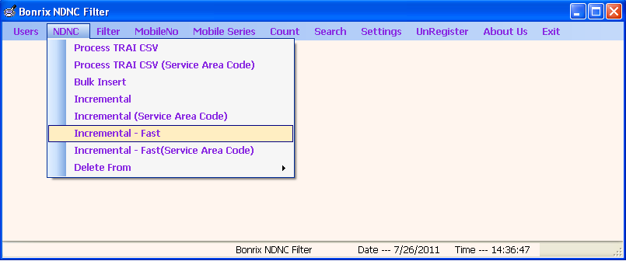

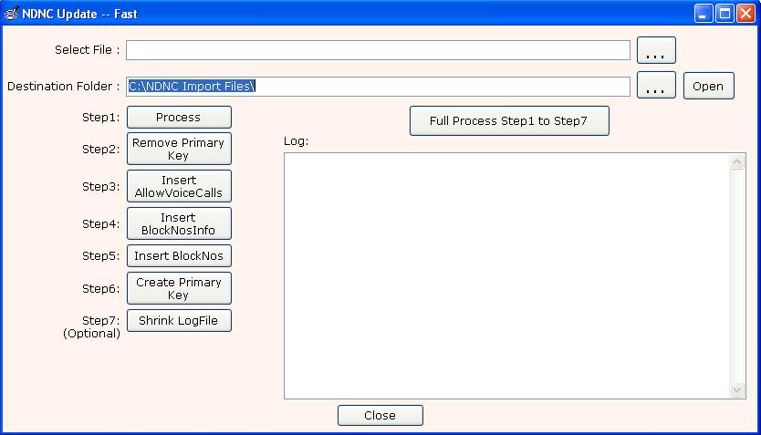
- It is used to update NDNC database.
- Source file as a incremental file which is downloaded form nccptrai.gov.in and destination folder as a any empty folder.
- Click on full process. (this process takes 30- 60 mins)

(2) Filter Block Numbers (Filter->Block Numbers):-Used for filter file

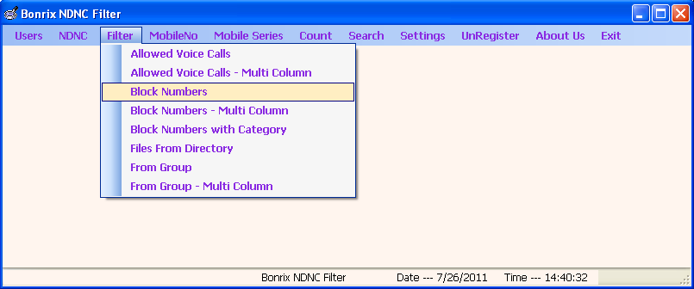

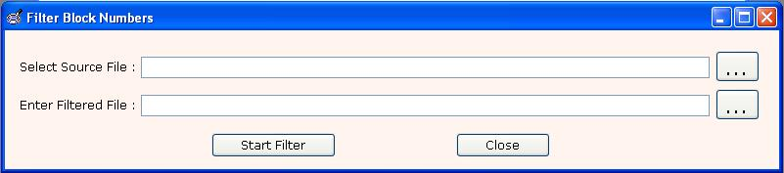
- To filter the Block Numbers give the source file path which you want to filter and give destination file path(just give name with extension like .xls or .csv ) and press Start Filter(only .txt, .csv and .xls files are allowed).
- Output is filtered Non-NDNC Numbers and second file is blocked numbers.
- Non-NDNC numbers are those on which you can make SMS Campaign.

(3) Filter Block Numbers Multi-Column (Filter->Block Numbers MultiColumn):- (if .csv or .xls file with Multiple Column)

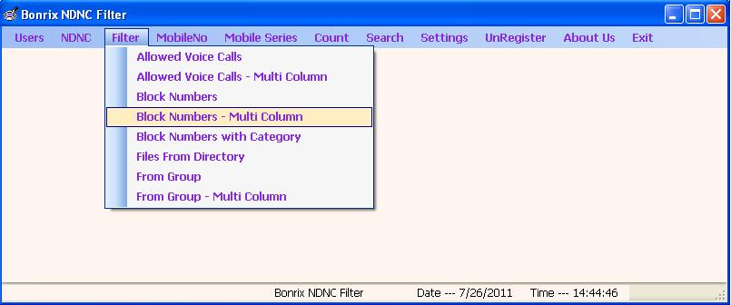

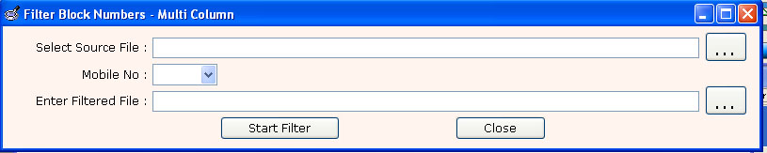
- To filter Block Numbres MultiColumn (source file contain multiple column) select source file and choose column in which Mobile No. resides and select destination file and press Start Filter(only .xls files are allowed).
- For multicolumn file file extension must be .xls
- Output is filtered Non-NDNC Numbers.
- Non-NDNC numbers are those on which you can make SMS Campaign.

(4) Count:-

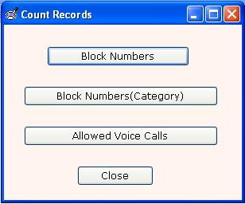
- It is used to count the phone no. Number in database.
  - Block Numbers - To Count Block Numbers form database.
  - Block Numbers(Category) - To Count Block Number(category)(e.g. Health, Real Estate )
  - Allowed Voice Call - To Count Allowed Voice Call Numbers.

